**Name: JOMOL R.k**

**Roll No:09**

**Batch:S2 MCA**

**Date:23-03-2022**

**NETWORKING & SYSTEM ADMINISTRATION LAB**

**Experiment No.: 1**

**Aim**

**Familiarization of LINUX commands**.

**Procedure**

**1.pwd(print working directory):**

**Print the current working directory path,starting from the root(/)**

**Syntax:**

**$pwd**

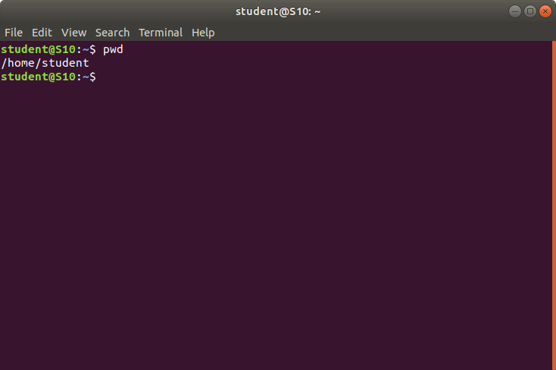

**2. mkdir(make directory):**

**Create a new directory wherever we want in our system**

**Syntax:**

**$mkdir ponnu**

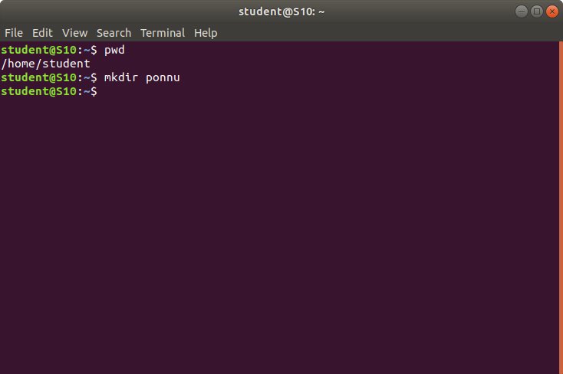

**3. ls:**

**It will show the full list or content of our directory,the whole content will be shown**

**Syntax:**

**$ls**

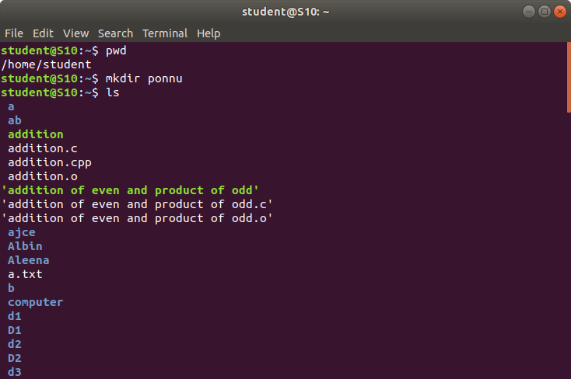

**4. man(manual page):**

**Man is an interface to view the system’s reference manual**

**Syntax:**

**$man ls**

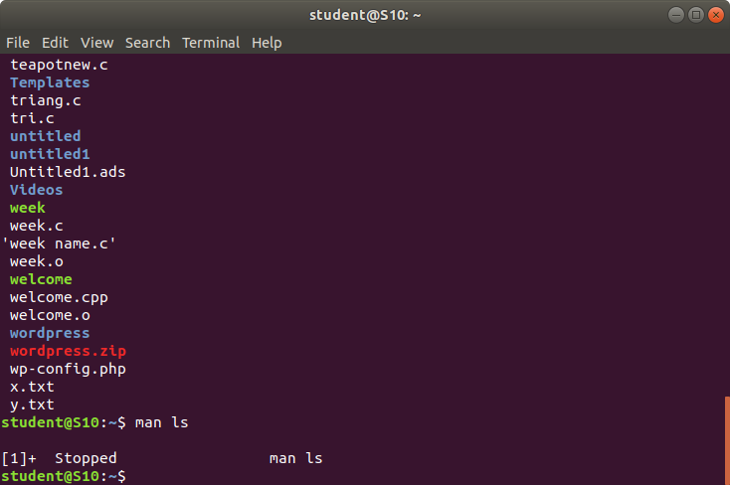

**5. ls -l:**

**It will show the list in a long list format**

**Syntax:**

**$ls -l**

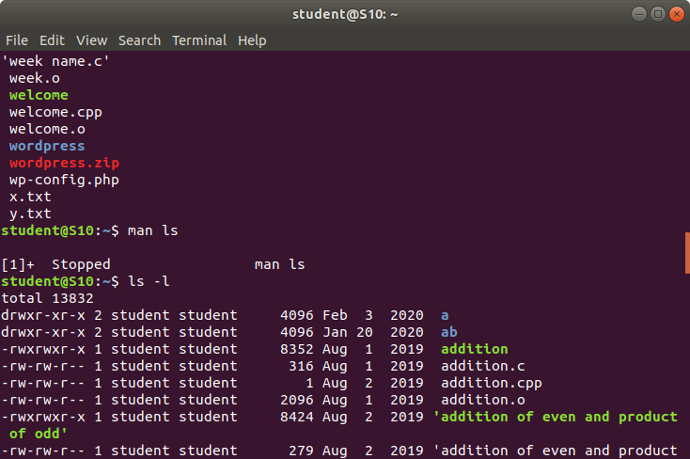

**6. ls -a:**

**The ls -a command enlist the whole list of the current directory including the hidden files.**

**Syntax:**

**$ls -a**

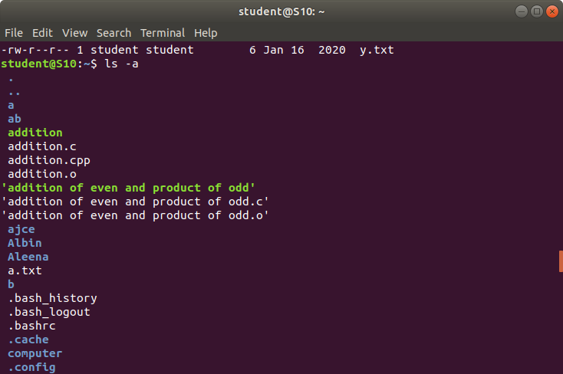

**7. ls -al:**

**Directory and files also it shows hidden files starting with dots**

**Syntax:**

**$ls -al**

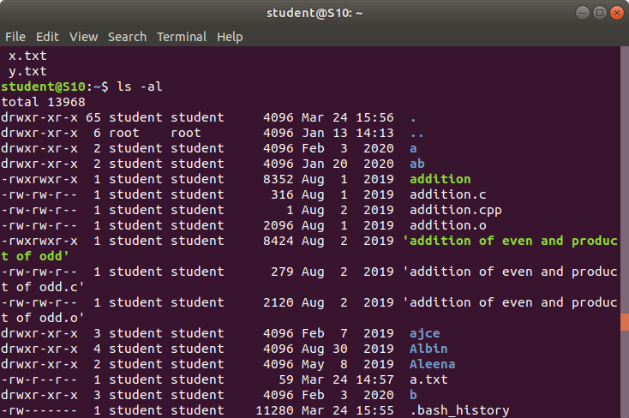

**8. ls -t:**

**Last modified directory ,subdirectory or files**

**Syntax:**

**$ls -t**

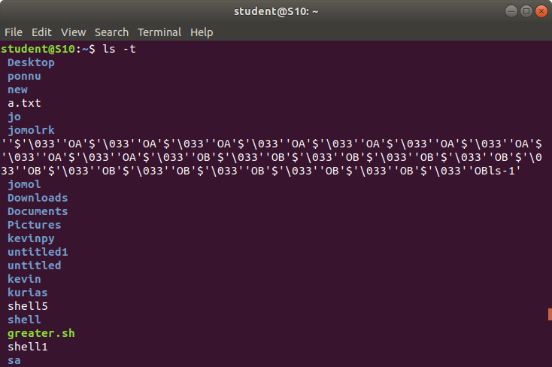

**9. cd <name of the directory>:**

**Change the current working directory**

**Syntax:**

**$cd ponnu**

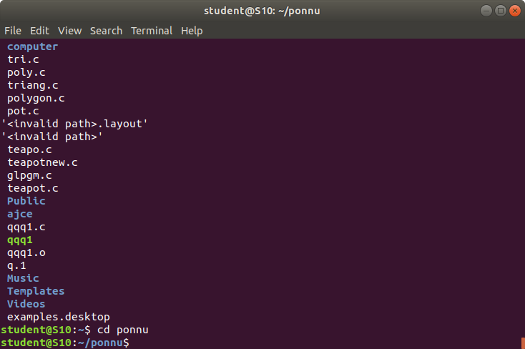

**10. cd .. :**

**Moving to the previous directory**

**Syntax:**

**$cd ..**

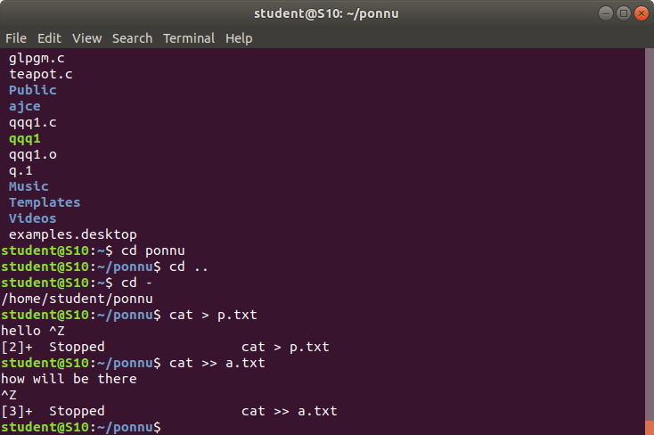

**11. cd - :**

**Back to the current directory**

**Syntax:**

**$cd -**

 **12. Cat > <filename>**

**To create new file**

**Syntax:**

**$cat > p.txt**



**13. cat >> <filename>**

**Inorder to add more contents**

**Syntax:**

**$cat >> a.txt**

